# CS 255 System Design Document

This template lays out all the different sections that you need to complete for Project Two. Each section has guidance to prompt your thinking. You will need to continually reference the interview transcript as you work to make sure that you are addressing your client’s needs. There is no required length for the final document. Instead the goal is to complete each section based on what your client’s needs are. Remove this note when you are finished, and replace all bracketed text with the relevant information.

## UML Diagrams

### UML Use Case Diagram

[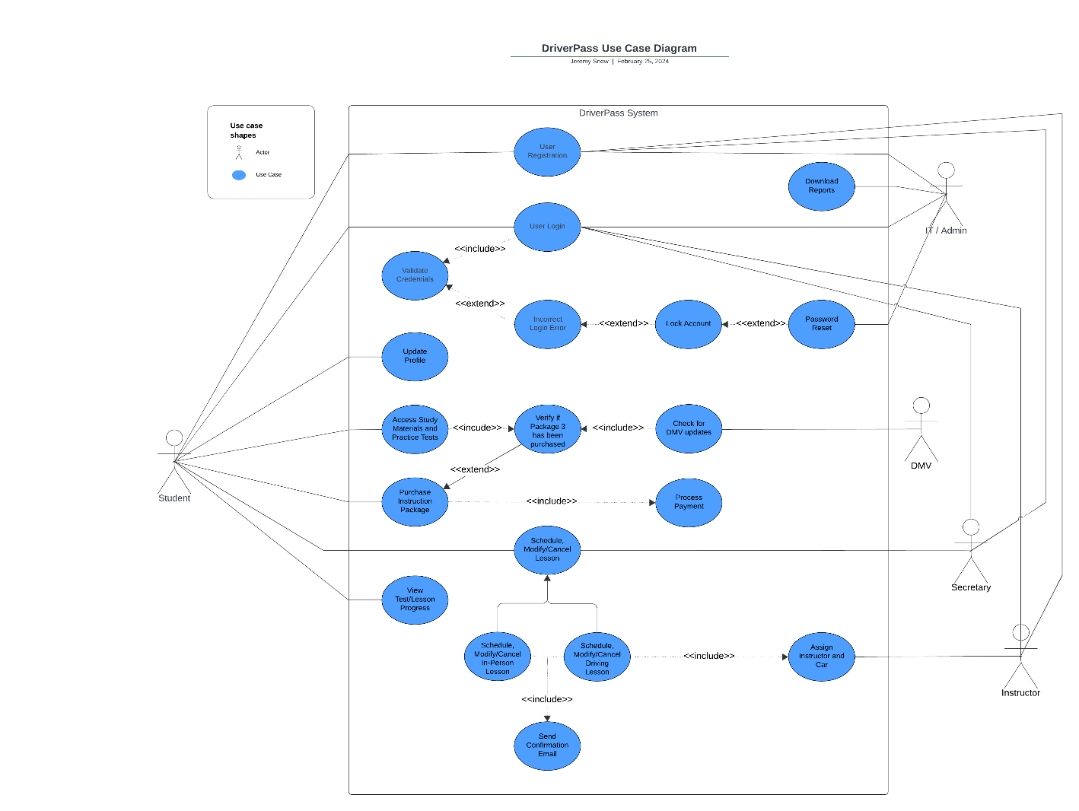](https://lucid.app/lucidchart/ee0646f6-f35d-416a-8a65-6e3492a02b2b/edit?crop=content&page=0&signature=da8a2d6a2a92926f49f13ca04a290722d42f830b0b5474710c5e37803d97c924)

### UML Activity Diagrams

[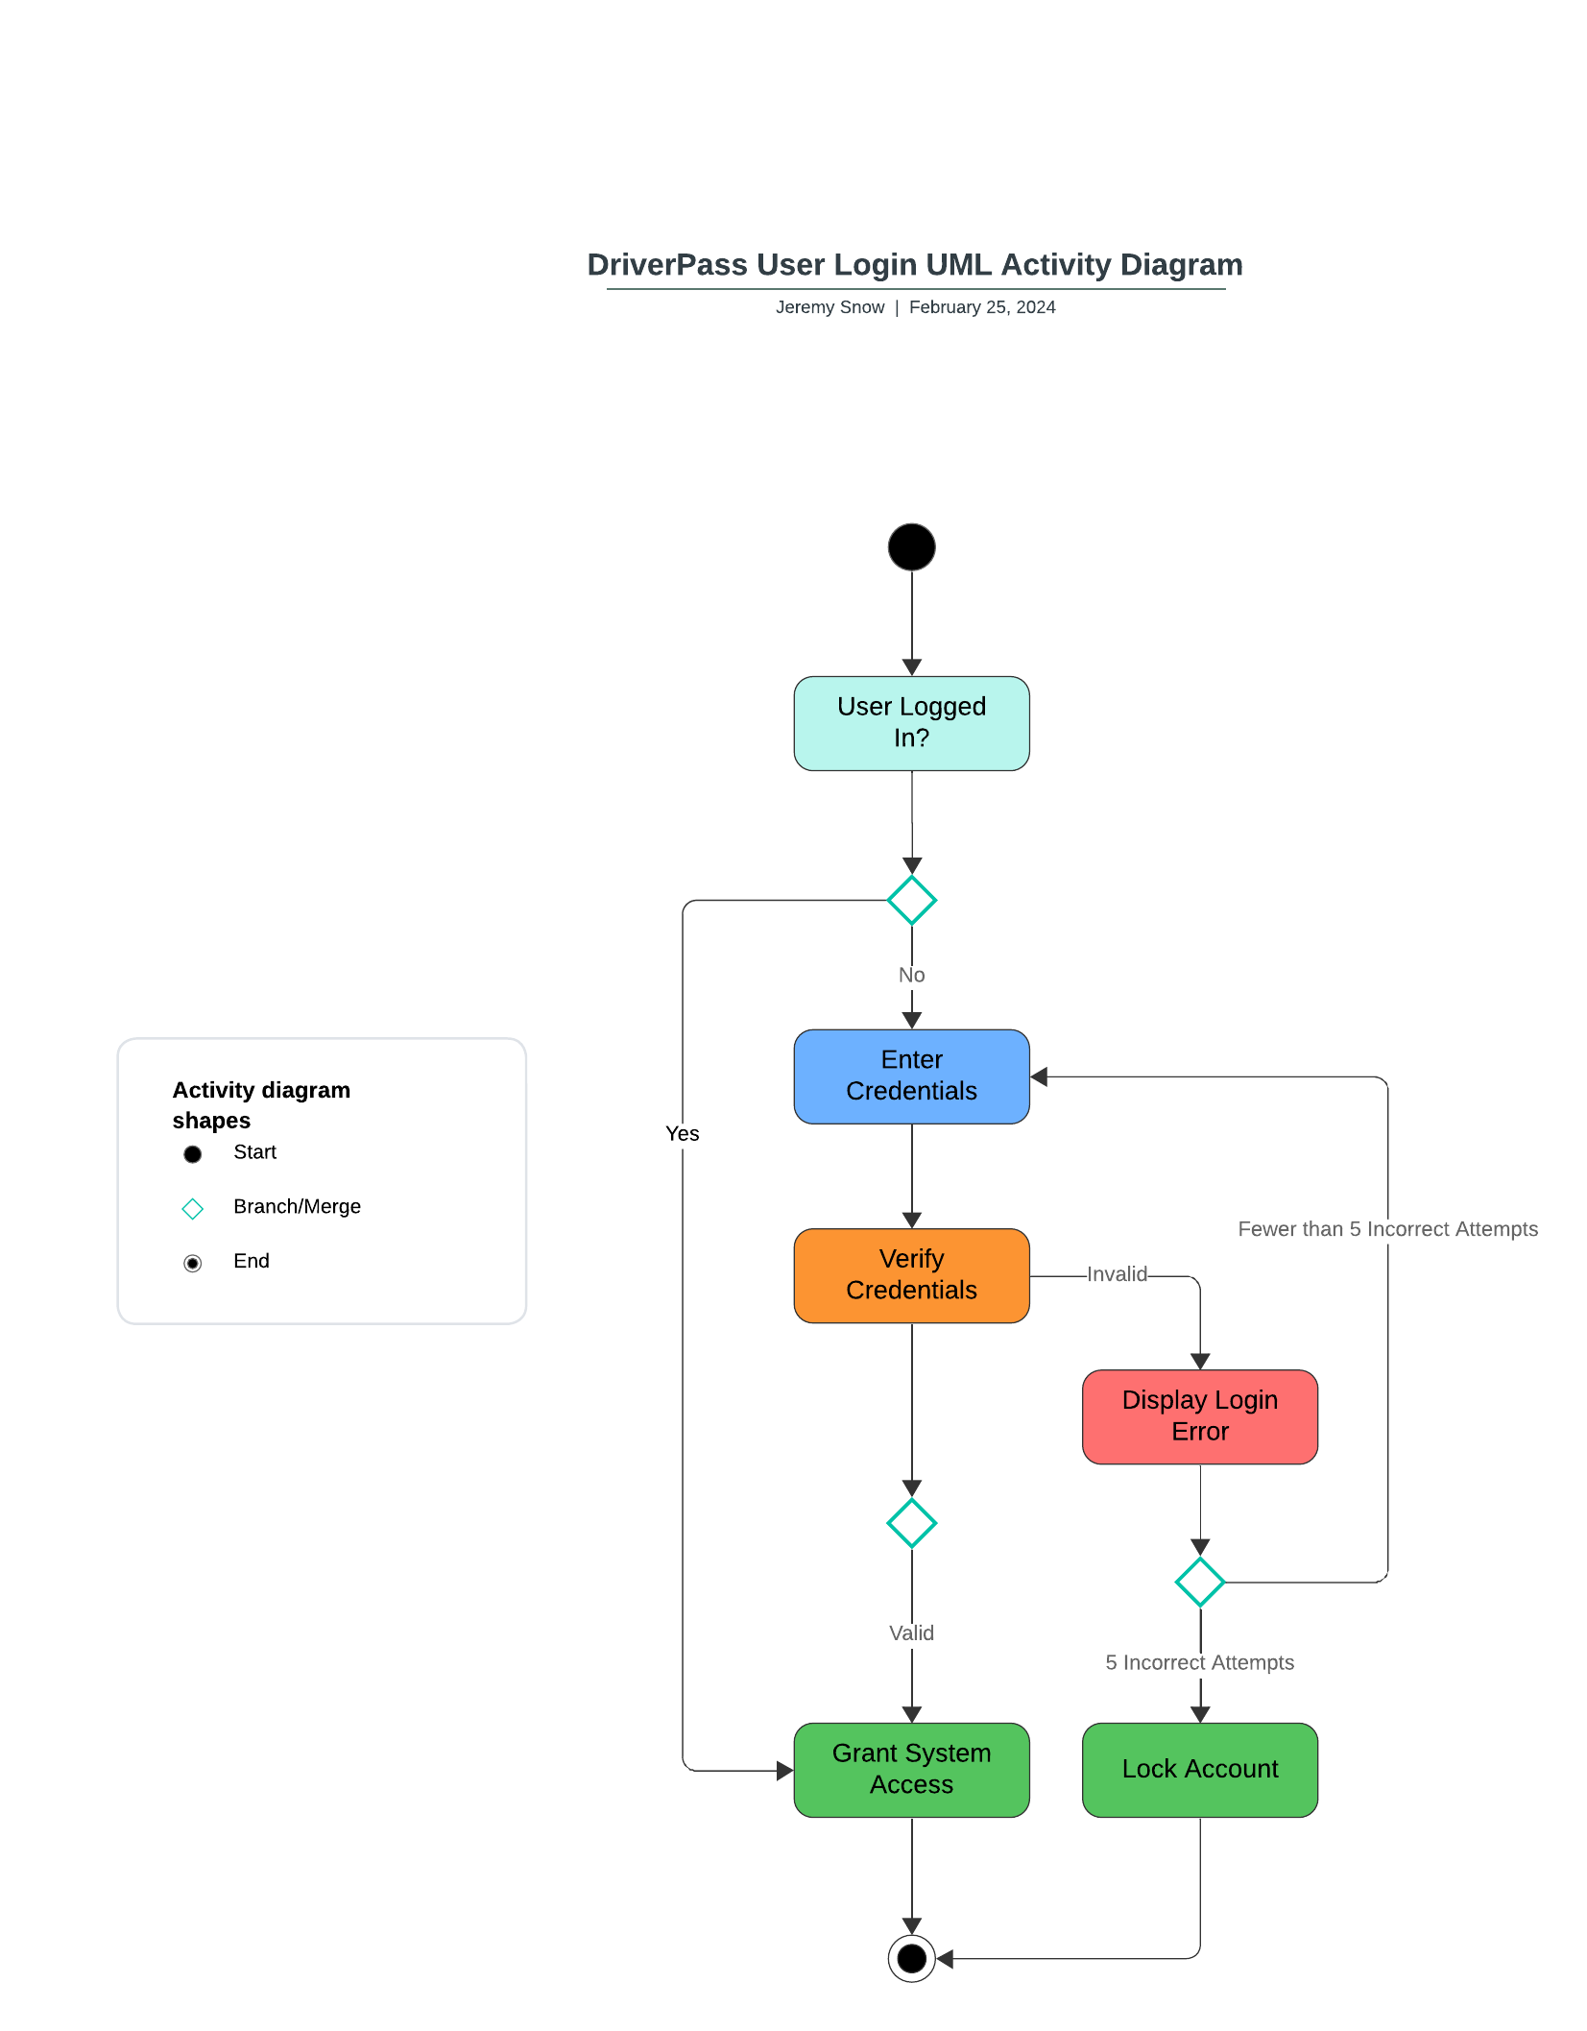](https://lucid.app/lucidchart/9d3012f4-fa97-4c09-ae80-0ccf34c0dc1c/edit?crop=content&page=0&signature=818b7390e1dd9b90dd67dfdd96663d627bdc97ac68298102ec98d265e92534c0)

### [DriverPass Schedule/Modify/Cancel Appointment UML Activity Diagram](https://lucid.app/lucidchart/b3fae729-b2a2-4670-9334-74e878baa003/edit?crop=content&page=0&signature=747cc4c0d94d6964d4c12f9d93b8566eb64d46bb8a913aa9c3dc6dde8c6ae29d)

### UML Sequence Diagram

[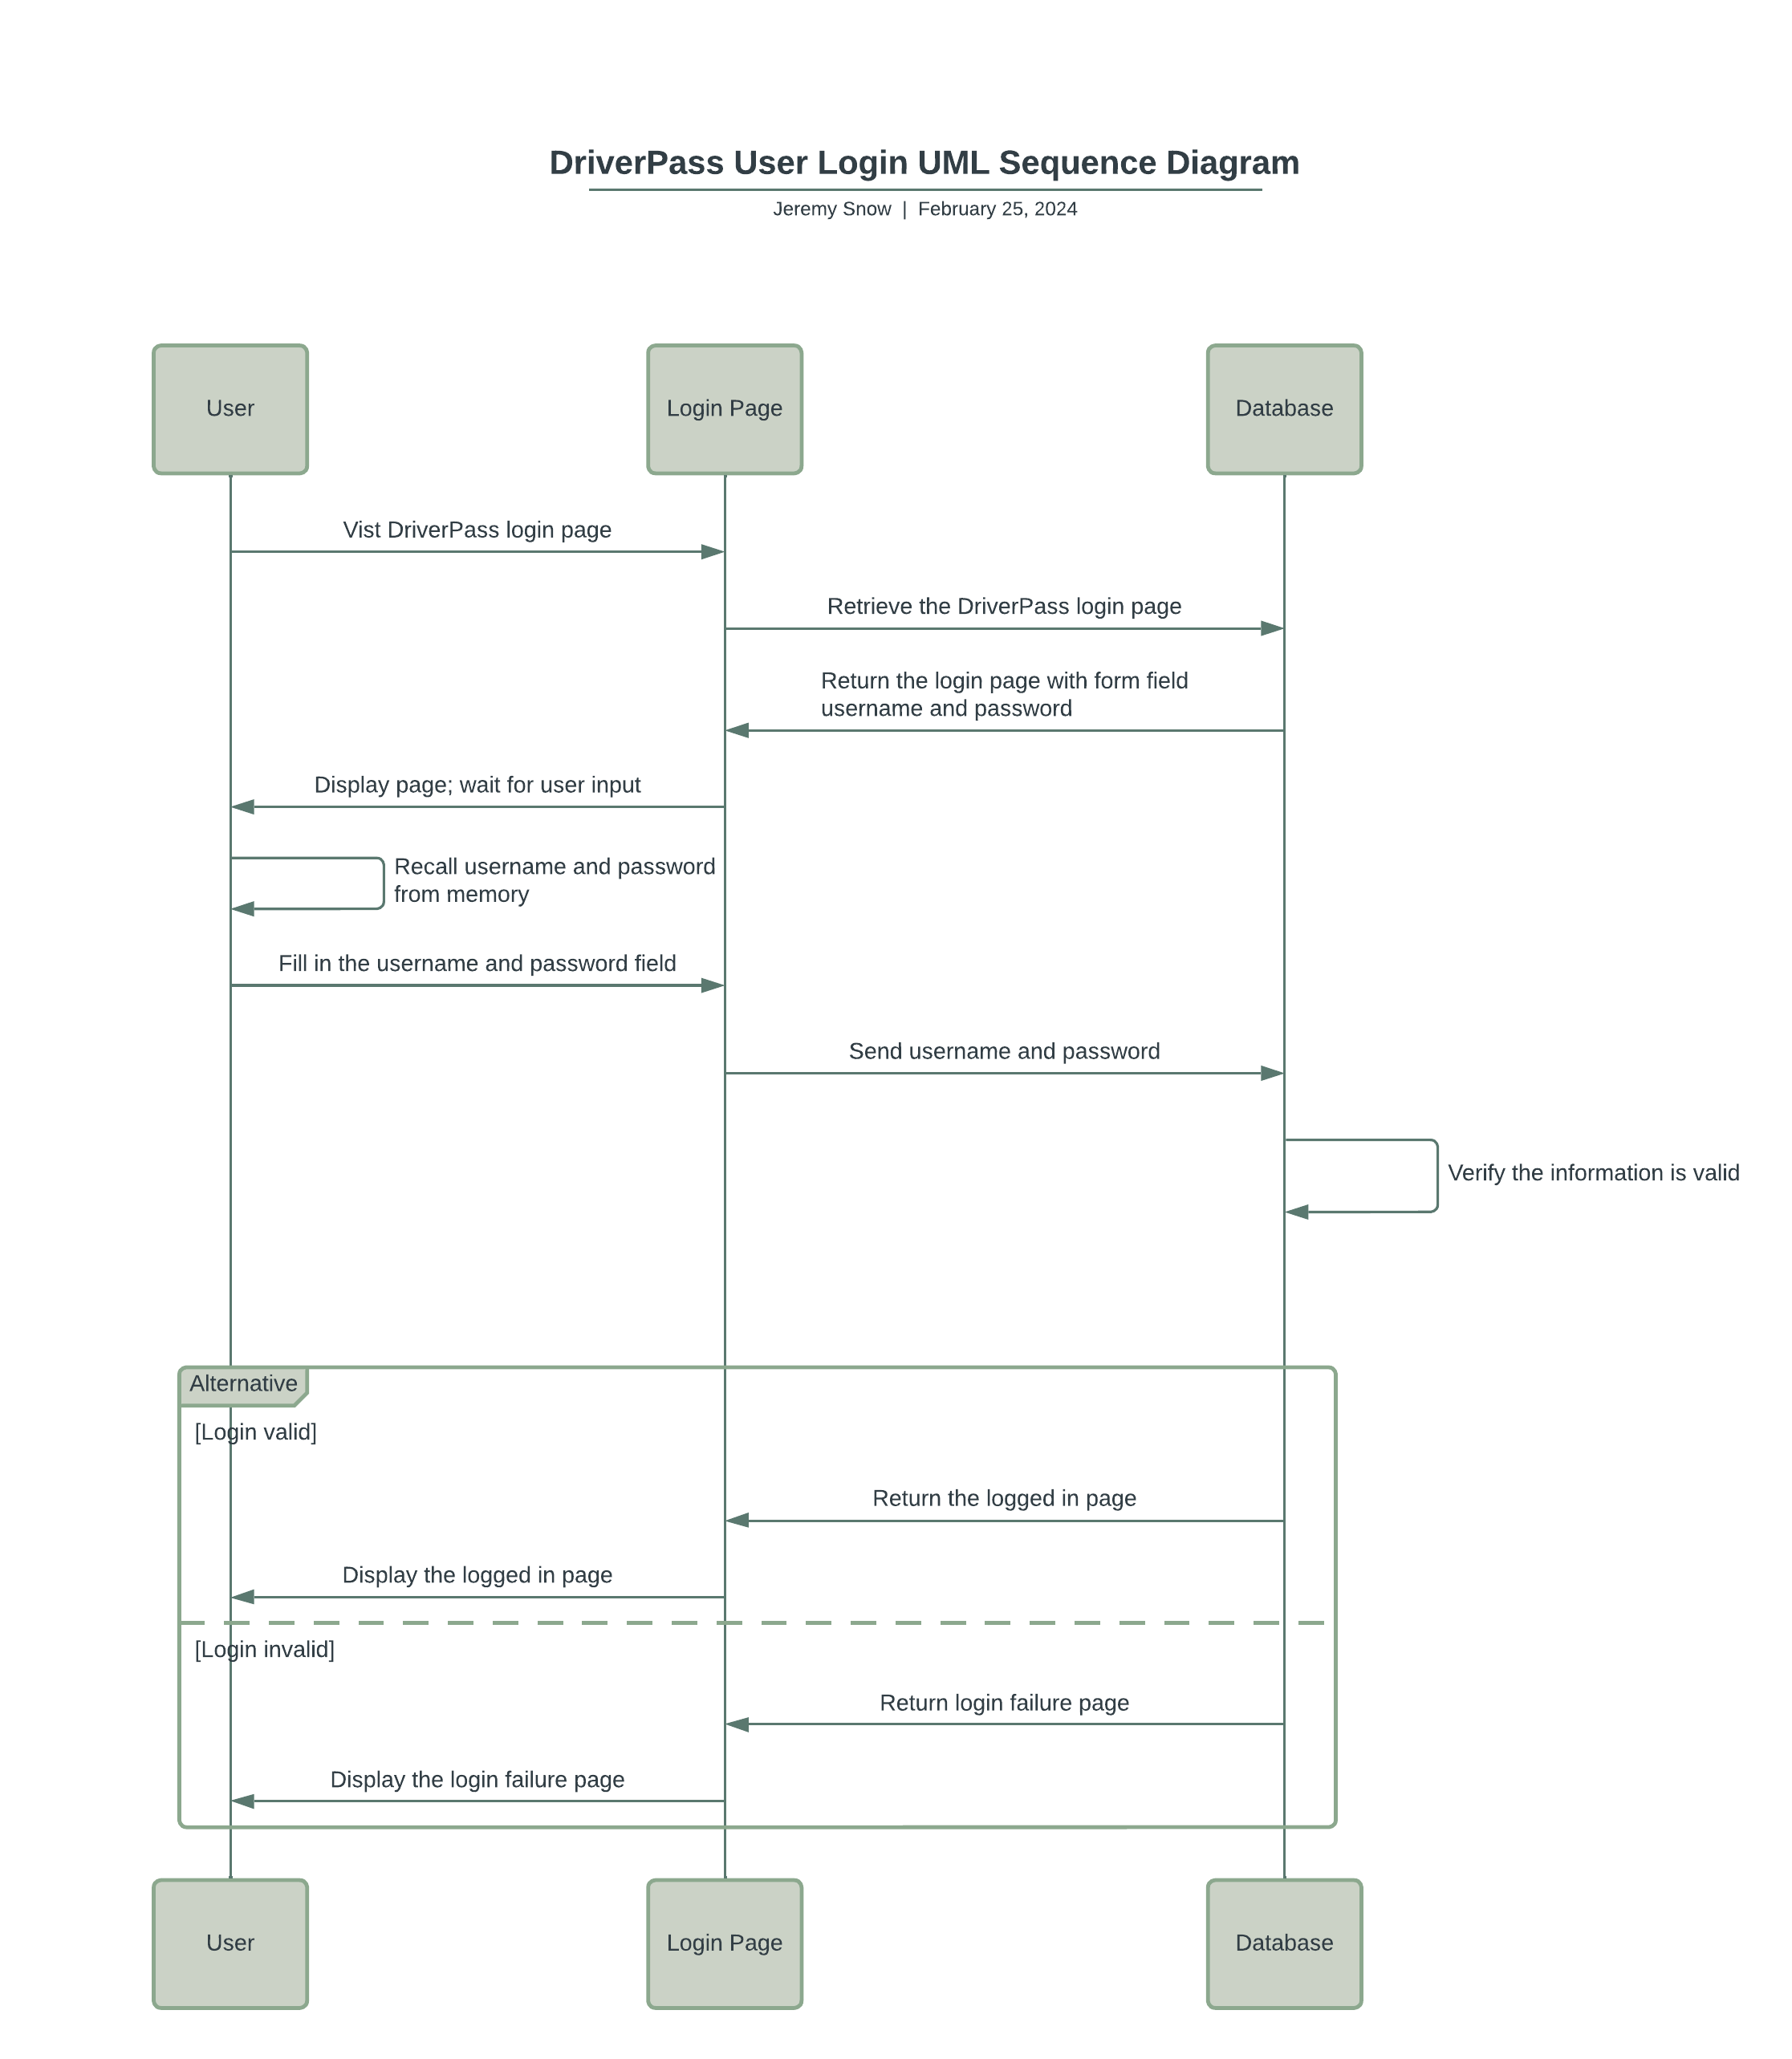](https://lucid.app/lucidchart/d646e17f-e4b2-454a-ad30-8d4d65cf8e82/edit?crop=content&page=0&signature=6639ac511c5f09484c19d7d584d6e679ef58e06c8e3162c206f09b16c10b5bed)

### UML Class Diagram

[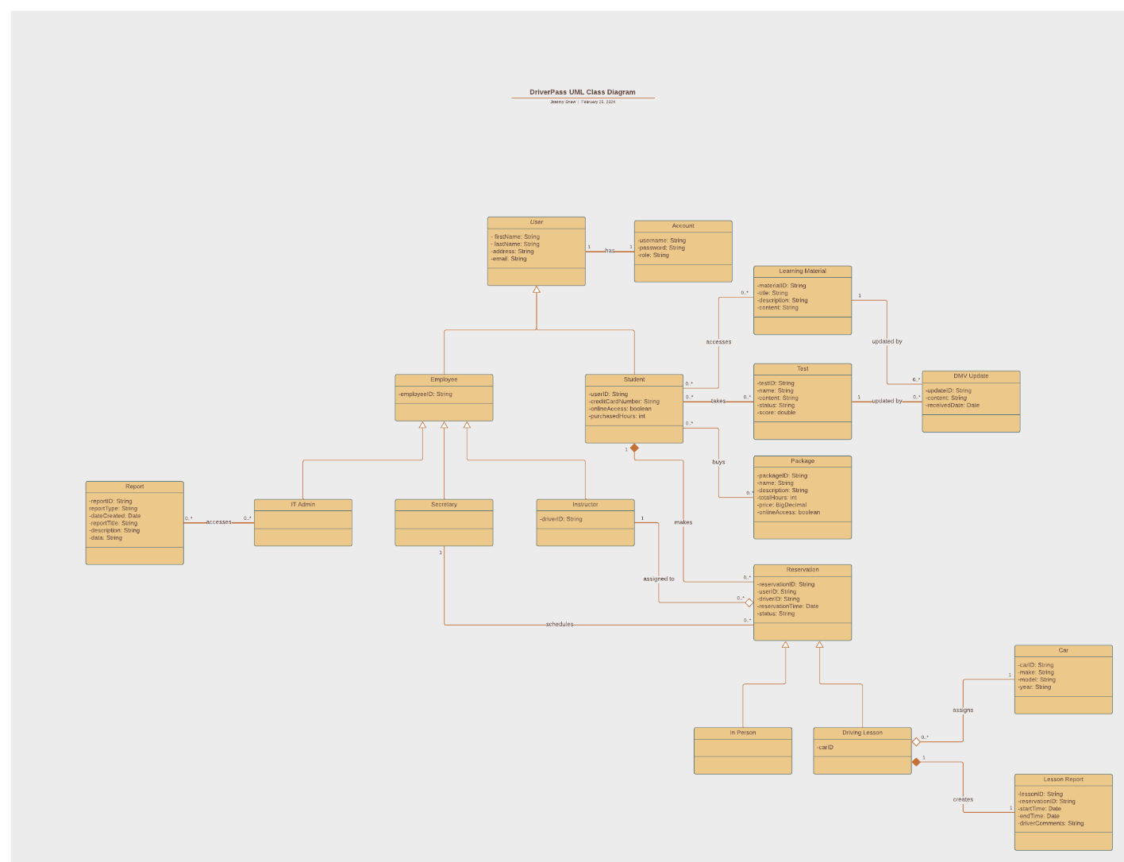](https://lucid.app/lucidchart/1cbdc843-4801-43ab-94d3-d41a99f4f936/edit?crop=content&page=0&signature=47928782ef9b040cf7e1fb208915cc474fa186cbc06a6b397ae2062d90160611)

## Technical Requirements

Hardware requirements for this system will include a computer or mobile device with access to the internet. The user will also require a supported browser to access the system. A service will be required to host the web application and storage will be required to contain application data, learning materials, and user data. In addition, the system will require networking infrastructure to ensure that the system stays connected to the internet reliably.

Software requirements will include a database management system, web server software, front-end technologies for developing the user interface, and an operating system for the user to access the system.

In order to develop the system, development tools will be required. These would include, but are not limited to, IDEs such as Eclipse, Visual Studio, or PyCharm. Continuous integration tools such as Jenkins or Travis CI will also aid in the development process.

The infrastructure required to support this system will include the cloud service that will be used for hosting, storage, and database purposes, encryption tools for data security, such as SSL, and backup and recovery solutions.